Project type: Engineering final

Project name: Impedance Control and compliance control with UR5 robot

Project facilitator details:

Moderator: Israel Shelheim, Prof. / H. Miriam Sachsenhaus

Phone: Israel: 0544258668

Email: schall@technion.ac.il, izzy.schall@gmail.com, [mermz@technion.ac.il](mailto:mermz@technion.ac.il)

Number of students per project: The project will be carried out by a pair of students

* **Project content:**

The SMILE (Sensory Motor Integration Laboratory) has recently developed algorithms for manipulating and assembling soft and / or flexible objects using a robotic arm. Examples include: (1) Assembling a rubber gasket inside a slot in a plastic box during the factory production process. (2) Wiring, (3) Connection of plastic pipes (in the medical industry). The project is part of the "Robotics in Industry" association, in which companies from the field of robotics and research laboratories in various academic institutions take part.

The core of the research that will be carried out in the laboratory by graduate students is the development of learning algorithms using the Reinforcement Learning method, with the bulk of the learning taking place in a simulator environment. The performance of the controllers studied will be compared to controllers developed using "classical" methods.

The purpose of the proposed project is to implement an algorithm for manipulating flexible objects using impedance control techniques. The implementation will be performed in a physical simulation (MuJoCo = Multi-joint with contacts) of a UR5 robot. The robot is in a laboratory, and the project will include the implementation of the algorithm on the robot depending on the success of the algorithm in the simulation and the availability of the robot.

* **Description of the project stages:**

1. Acquisition of theoretical background in impedance-based control techniques
2. Implementation of a simulation of the basic concept in MuJoCo or MATLAB
3. Implementation of the algorithm in the simulation
4. Examining the performance of the algorithm and the effects of the parameters of the controller
5. (Optional): Implementation of the algorithm on the robot

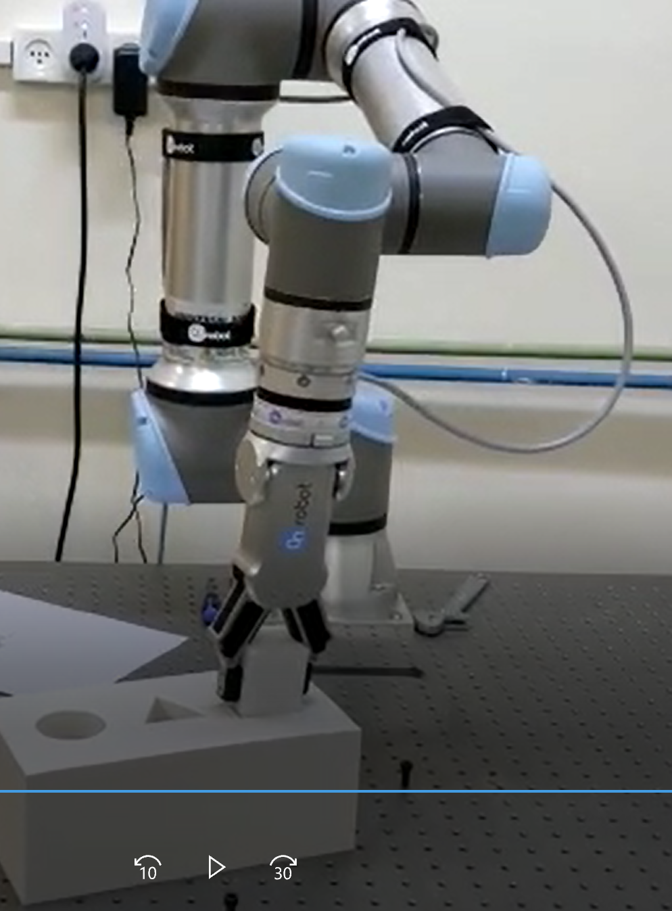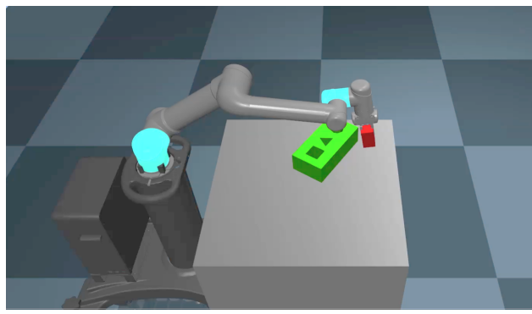

A UR5 robot simulation performs a simple assembly operation in a MuJoCo environment

The UR5e robot performs a laboratory assembly operation

* **Tools to be acquired during the project:**
* Impedance Control
* Python programming
* Programming in a MuJoCo environment - physical simulation of multi-joint and contact bodies (Multi Joints with Contacts)
* **Prerequisites:**

Good programming skills (experience only in MATLAB is also accepted)

Required to take the following courses (also possible during the project): Introduction to Robotics, Control Theory,

Recommended to take: Neural networks

* **References**
* Impedance control Wiki <https://en.wikipedia.org/wiki/Impedance_control#:~:text=February%202014)%20(Learn%20how%20and,position%20relation%20is%20of%20concern.>
* 联想
* 柔性机器，leopard：每次落地时的反冲决定下一次用力的大小，平衡的控制，etc